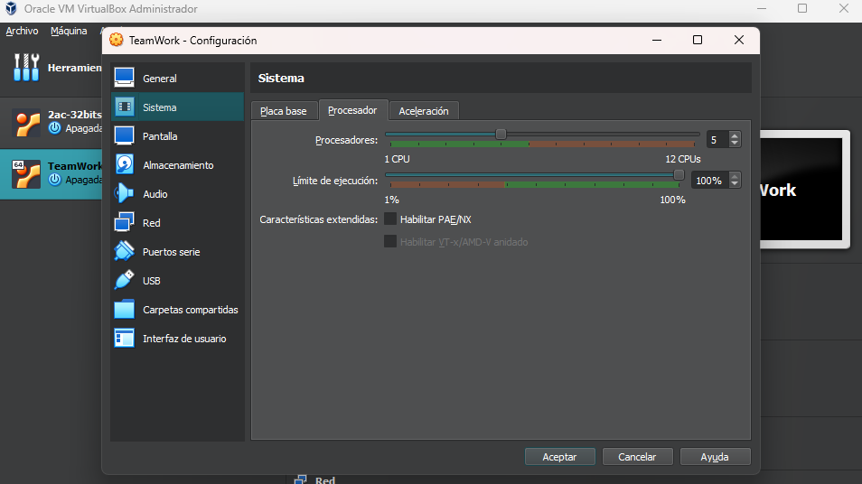Configuración del procesador de la máquina virtual:

Copia del fichero /proc/cpuinfo:

processor : 0

vendor_id : GenuineIntel

cpu family : 6

model : 158

model name : Intel(R) Core(TM) i7-8750H CPU @ 2.20GHz

stepping : 10

cpu MHz : 2208.000

cache size : 9216 KB

physical id : 0

siblings : 5

core id : 0

cpu cores : 5

apicid : 0

initial apicid : 0

fpu : yes

fpu_exception : yes

cpuid level : 22

wp : yes

flags : fpu vme de pse tsc msr pae mce cx8 apic sep mtrr pge mca cmov pat pse36 clflush mmx fxsr sse sse2 ht syscall nx rdtscp lm constant_tsc rep_good nopl xtopology nonstop_tsc cpuid tsc_known_freq pni pclmulqdq ssse3 cx16 pcid sse4_1 sse4_2 x2apic movbe popcnt aes xsave avx rdrand hypervisor lahf_lm abm 3dnowprefetch invpcid_single pti fsgsbase bmi1 avx2 bmi2 invpcid rdseed clflushopt md_clear flush_l1d

bugs : cpu_meltdown spectre_v1 spectre_v2 spec_store_bypass l1tf mds swapgs itlb_multihit srbds mmio_stale_data retbleed

bogomips : 4416.00

clflush size : 64

cache_alignment : 64

address sizes : 39 bits physical, 48 bits virtual

power management:

processor : 1

vendor_id : GenuineIntel

cpu family : 6

model : 158

model name : Intel(R) Core(TM) i7-8750H CPU @ 2.20GHz

stepping : 10

cpu MHz : 2208.000

cache size : 9216 KB

physical id : 0

siblings : 5

core id : 1

cpu cores : 5

apicid : 1

initial apicid : 1

fpu : yes

fpu_exception : yes

cpuid level : 22

wp : yes

flags : fpu vme de pse tsc msr pae mce cx8 apic sep mtrr pge mca cmov pat pse36 clflush mmx fxsr sse sse2 ht syscall nx rdtscp lm constant_tsc rep_good nopl xtopology nonstop_tsc cpuid tsc_known_freq pni pclmulqdq ssse3 cx16 pcid sse4_1 sse4_2 x2apic movbe popcnt aes xsave avx rdrand hypervisor lahf_lm abm 3dnowprefetch invpcid_single pti fsgsbase bmi1 avx2 bmi2 invpcid rdseed clflushopt md_clear flush_l1d

bugs : cpu_meltdown spectre_v1 spectre_v2 spec_store_bypass l1tf mds swapgs itlb_multihit srbds mmio_stale_data retbleed

bogomips : 4416.00

clflush size : 64

cache_alignment : 64

address sizes : 39 bits physical, 48 bits virtual

power management:

processor : 2

vendor_id : GenuineIntel

cpu family : 6

model : 158

model name : Intel(R) Core(TM) i7-8750H CPU @ 2.20GHz

stepping : 10

cpu MHz : 2208.000

cache size : 9216 KB

physical id : 0

siblings : 5

core id : 2

cpu cores : 5

apicid : 2

initial apicid : 2

fpu : yes

fpu_exception : yes

cpuid level : 22

wp : yes

flags : fpu vme de pse tsc msr pae mce cx8 apic sep mtrr pge mca cmov pat pse36 clflush mmx fxsr sse sse2 ht syscall nx rdtscp lm constant_tsc rep_good nopl xtopology nonstop_tsc cpuid tsc_known_freq pni pclmulqdq ssse3 cx16 pcid sse4_1 sse4_2 x2apic movbe popcnt aes xsave avx rdrand hypervisor lahf_lm abm 3dnowprefetch invpcid_single pti fsgsbase bmi1 avx2 bmi2 invpcid rdseed clflushopt md_clear flush_l1d

bugs : cpu_meltdown spectre_v1 spectre_v2 spec_store_bypass l1tf mds swapgs itlb_multihit srbds mmio_stale_data retbleed

bogomips : 4416.00

clflush size : 64

cache_alignment : 64

address sizes : 39 bits physical, 48 bits virtual

power management:

processor : 3

vendor_id : GenuineIntel

cpu family : 6

model : 158

model name : Intel(R) Core(TM) i7-8750H CPU @ 2.20GHz

stepping : 10

cpu MHz : 2208.000

cache size : 9216 KB

physical id : 0

siblings : 5

core id : 3

cpu cores : 5

apicid : 3

initial apicid : 3

fpu : yes

fpu_exception : yes

cpuid level : 22

wp : yes

flags : fpu vme de pse tsc msr pae mce cx8 apic sep mtrr pge mca cmov pat pse36 clflush mmx fxsr sse sse2 ht syscall nx rdtscp lm constant_tsc rep_good nopl xtopology nonstop_tsc cpuid tsc_known_freq pni pclmulqdq ssse3 cx16 pcid sse4_1 sse4_2 x2apic movbe popcnt aes xsave avx rdrand hypervisor lahf_lm abm 3dnowprefetch invpcid_single pti fsgsbase bmi1 avx2 bmi2 invpcid rdseed clflushopt md_clear flush_l1d

bugs : cpu_meltdown spectre_v1 spectre_v2 spec_store_bypass l1tf mds swapgs itlb_multihit srbds mmio_stale_data retbleed

bogomips : 4416.00

clflush size : 64

cache_alignment : 64

address sizes : 39 bits physical, 48 bits virtual

power management:

processor : 4

vendor_id : GenuineIntel

cpu family : 6

model : 158

model name : Intel(R) Core(TM) i7-8750H CPU @ 2.20GHz

stepping : 10

cpu MHz : 2208.000

cache size : 9216 KB

physical id : 0

siblings : 5

core id : 4

cpu cores : 5

apicid : 4

initial apicid : 4

fpu : yes

fpu_exception : yes

cpuid level : 22

wp : yes

flags : fpu vme de pse tsc msr pae mce cx8 apic sep mtrr pge mca cmov pat pse36 clflush mmx fxsr sse sse2 ht syscall nx rdtscp lm constant_tsc rep_good nopl xtopology nonstop_tsc cpuid tsc_known_freq pni pclmulqdq ssse3 cx16 pcid sse4_1 sse4_2 x2apic movbe popcnt aes xsave avx rdrand hypervisor lahf_lm abm 3dnowprefetch invpcid_single pti fsgsbase bmi1 avx2 bmi2 invpcid rdseed clflushopt md_clear flush_l1d

bugs : cpu_meltdown spectre_v1 spectre_v2 spec_store_bypass l1tf mds swapgs itlb_multihit srbds mmio_stale_data retbleed

bogomips : 4416.00

clflush size : 64

cache_alignment : 64

address sizes : 39 bits physical, 48 bits virtual

power management:

Imágenes a usar: bailarina_wb1.bmp

Trabajo realizado por Miguel: rellenar el main.cpp y seleccionar el tipo de datos con el que se va a trabajar, en nuestro caso es el tipo double.